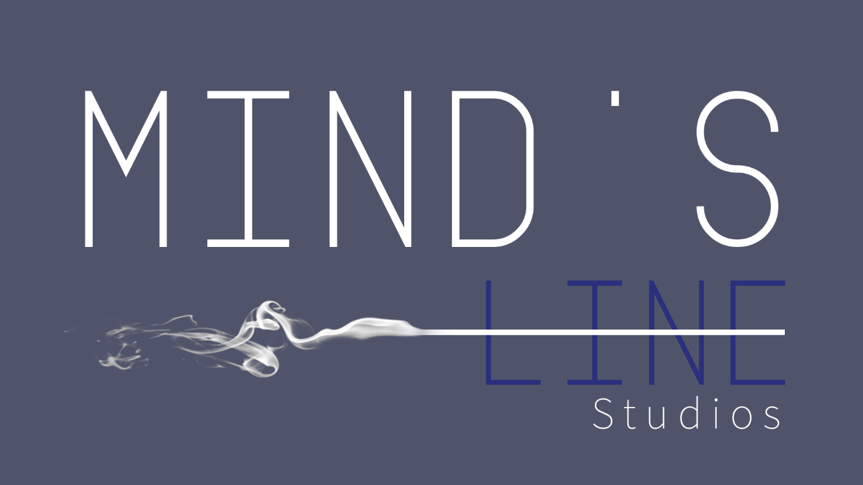
Design Document for:

Mind's Line

A Liminal Space Horror Walking Sim

All work Copyright ©2022 by Mind's Line Studios

By Andrew Carvalho-O'dell, Gonçalo Miranda, Lorena Neagoe, Scott Ollard

Version # 1.0

Saturday, April 04, 2022
Table of Contents

NAME OF GAME 1 DESIGN HISTORY 5
VERSION 1.10 5
VERSION 2.00 5
VERSION 2.10 5

GAME OVERVIEW 6
DESIGN GOALS 6
Goal #1 6
Goal #2 6
Goal #3 6
COMMON QUESTIONS 6
What is the game? 6 Why create this game? 6 Where does the game take place? 6 What do I control? 6 How many characters do I control? 6 What is the main focus? 7 What’s different? 7

FEATURE SET 8
GENERAL FEATURES 8 EDITOR 8 GAMEPLAY 8

THE GAME WORLD 9
OVERVIEW 9
SUPERNATURAL ELEMENTS 9
SLOWLY SHIFTING ROOMS 9 WORLD DETAILS 9
Overview 9
Key Locations 9
Travel 9
Scale 9
Objects 9
Weather 9 Day and Night 9 Time 10 RENDERING SYSTEM 10
Overview 10 Unreal Engine Rendering 10 CAMERA 10
Overview 10
Emphasized Horror 10
Technical Simplicity 10
GAME ENGINE 10
Overview 10
Easy Organization 10
Collision Detection 10
LIGHTING MODELS 11
Overview 11 Office Lighting 11 Hospital Lighting 11

THE WORLD LAYOUT 12
OVERVIEW 12

GAME CHARACTERS 13
OVERVIEW 13 Character Minimalism 13

USER INTERFACE 14
OVERVIEW 14
Less is More 14
Keeping Immersion 14

SOUND DESIGN 16
OVERVIEW 16 SPOOKY ATMOSPHERE 16

SINGLE PLAYER GAME 17
OVERVIEW 17 STORY 17 PLAYTIME 17 VICTORY CONDITIONS 17

CHARACTER RENDERING 19
OVERVIEW 19
IN THE HOSPITAL ROOM 19

Design History
In the paragraphs bellow, the progression of the game’s development will be detailed, from the initial to it’s last and latest version. With this, the changes and differences between them will be made clear.

Version 1.10
For Version 1.10, we changed how the game would progress and radically changed the idea for the narrative:

- We added a proper narrative, where there wasn’t a proper one before.

- The structure of the level was changed slightly, new areas were added and some were either moved around or removed.

- The horror aspect was changed to be more clear and direct, since subtle horror might be out of our skill level.

Version 2.00

Version 2.10

Game Overview

Design Goals

Goal #1

Create an interesting and unpredictable experience for the player, since the type of storytelling and horror we are trying to recreate is unusual and mainly characterized by it’s unpredictability.

Goal #2

Represent the source material well, as we feel it to be an interesting and unusual method of horror storytelling.

Goal #3

Create memorable and unique visuals, mainly through level design, which is the draw of Backrooms stories.

Common Questions

What is the game?

Mind's Line is a liminal space horror walking sim that is based on the popular creepy pasta called “The Backrooms”.

The game is set in a limbo that looks like a modern high rise office, where an office worker falls asleep and then awakens to explore their new surreal environment. As they walk around the office, they slowly find out what really happened.

Why create this game?
The original creepypasta has recently sparked our interest and we wanted to make our own take on it, with the slight twist of having a proper narrative, which is rare in stories based on our source material.
Where does the game take place?

The game takes place in a high rise office setting, which turns out to actually be a surreal limbo.

What do I control?

The player will control a regular office worker who awakens at their desk.

How many characters do I control?

The player can only control the office worker.

What is the main focus?

The main focus of this game is to find out what the reason for being transported to this surreal reality really is.

What’s different?

Mind's Line is attempting to be a liminal space horror game with a stor, which for this type of game, it’s at best, a rare thing. Additionally, the lack of story is part of the horror, but we are thinking of substituting it with more story.

Feature Set

General Features
Walking Simulator Psychological Horror Indirect/Subtle Narrative

Editor
Comes with world editor Get levels from Internet Editor is super easy to use

Gameplay
The gameplay mainly consists of walking through increasingly unnatural office rooms, with occasional hints at the reason behind the strange reality. Sometimes a shadow with no body will show up, but this doesn’t affect gameplay.
The only interactables will be doors and a small number of items.

The Game World

Overview
The game world consists of a few floors belonging to an limbo-like reality trying to imitate an office building.

Supernatural Elements
As the player progresses, usually normal office rooms would slowly change: furniture arranged in odd ways, impossibly high ceilings and layouts that don’t make sense.

Slowly Shifting Rooms
At some point in the game, objects from a hospital would pop up one after another in the office rooms and eventually, the rooms the player would go through are turned into hospital rooms and hallways.

World Details

Key Locations

The Starting Floor: The first floor where the player would begin the game is open to explore, with the intention of making the player comfortable and unaware of the fact that they’ve been transported to an alternate reality.

Window Room: This is where the player character would first discover that they’re not in the real world and would present the game’s main visual.

Shifting Office: 3 repeating office rooms that get progressively more unnatural.

Hospital Lounge: The largest room in the game, with the second key visual of the game and the first big hint that the levels are shifting to hospital rooms.

Hospital Bedroom: The last room in the game and where the player character would realize what’s happened.

Travel

The only way of traversing through the world is walking.

Scale

The scale would be kept realistic, with the exception of in moments where we want to convey the supernatural aspects of the game and story. The main example, as mentioned previously, would be rooms that are unnaturally sized in comparison to others, to communicate to the player and character that something is going on with their world.

Objects

The player character would be able to find a couple of items throughout the few levels, mainly pamphlets relating to their real world situation and to hint at the reason behind the supernatural events .

Time

As the player character is transported to an alternate reality/limbo, the in-game time will be static.

Rendering System

Overview

The objective is to render the game realistically. Realism is a major elements of Backrooms stories, where the realism contrasted with the unnatural room formations and other supernatural elements is what makes these stories scary.

Unreal Engine Rendering

For our game, we’ll use the Unreal Engine, specifically Unreal Engine 4. It’s a great and easy tool to create any game, and it’s more than capable of creating ours. It’s rendering engine has been used to create other Backrooms games and to great effect.

Camera

Overview

As is custom in all Backrooms games, the camera we’ll be using is a First Person camera.

Emphasized Horror

Since the Backrooms’ horror comes from, among other things, it being able to happen to anyone, using a Third Person camera would lessen the effect of the intended horror, as the player would be less able to place themselves in that situation.

Technical Simplicity

On top of a better experience for the player, creating a First Person camera is easier on the developers, since it saves us time that otherwise would have been spent creating, rigging and animating a character.

Game Engine

Overview

Our Game Engine, as mentioned before, will be the Unreal Engine 4.

Easy Organization

On top of other already mentioned aspects, the Unreal Engine makes organizing assets simple and easy. For our environment, the reuse of assets is inevitable, so this aspect of the engine is a big help.

Collision Detection

As for our game’s collision, it will be very simple overall. The main obstacle is to make sure the player doesn’t go anywhere unintended and that doors and other moving assets in the environment work as intended and keep the player in the right path.

Lighting Models

Overview

We’re trying to achieve realism with our lighting, to better fit the intended style.

Office Lighting

For the office sections of our game, we’re taking inspiration from the typical lighting of a common modern office: ceiling lights, exit signs and the nighttime sky through the windows. The more mundane and common it looks the better.

Hospital Lighting

For the hospital sections, a more sterile and colder look is the intention. White lights paired with light tones of blue and grey in the environment to give this oppressive yet semi climactic feeling of nearing the end of the journey.

The World Layout

Overview
The layout of the levels is quite simple. Initially, the player has a bit of freedom to move around, but throughout the game, the levels progressively get linear.

Progressive Linearity
At the start of the game, the player will be able to explore one small floor of the office building. There’s a proper way to progress past this level and the player will be hinted at what this way is and where it is, but they’ll have the freedom to look around.

Game Characters

Overview
The game will have 2 characters: the Office Worker that the player controls and the Shadow without a body that will show up at some points throughout the game.

Character Minimalism
For our Office Worker, we wanted them to be as unintrusive to the player as possible, like a blank slate character.
There will be a story to follow, but the character the player experiences it through will be like a name in the pages of a book: the character exists, but it’s easier for the reader to put themselves in their place.

User Interface

Overview
Our aim with the User Interface is to make it minimal and unintrusive. With Backrooms stories, to an extent, the less is shown, the better.
And with our UI, the same rules should apply.

Less is More
Minimalism is our goal with the visuals, so our Heads-Up Display will show only the critical essentials to make the experience functional:
Button Prompts: When the player is given something to interact with, a Button Prompt will appear. This is also look small and plain;
Inner Dialogue: At certain points in the game, text will show up as subtitles to the characters thoughts on the situation they’re currently experiencing.

Keeping the Immersion
A clean and minimal UI and HUD helps immensely with immersion in any game.
The more the player can see of the world they’re trying to experience, the easier it will be for them to be sucked into it’s universe.

Sound Design

Overview
Sound will play an important part in our game. Since the game’s objective is to give the player a mellow yet oppressive environment, level and sound design need to do the heavy lifting when it comes to the atmosphere of the game.

Spooky Atmosphere
Throughout the game, sound will be used to draw the player’s attention to certain events or parts of the room: a sound might bring their attention to an item they can interact with or point them to where to go.
Other times, sound will be used to simply keep the atmosphere spooky and tense: whispers, voices behind closed doors or footsteps where no people can be found.
The direction and origin of these sounds will not always be the same or clear to the player.

Single-Player Game

Overview

Mind’s Line is a linear single player game, so it’s story is told in a linear way: as the player progresses through the game, the story is revealed to them.

Story
It’s a late night at a Highrise office in NY, where one of the workers just finished writing a report. They’re tired, enough to pass out on their desk. As soon as they wake up, they wonder why no one's come to wake them up, but nonetheless get up to leave, but after crossing a couple of rooms, differences start to show. Rooms seem flipped, doors leading to different rooms than normal and the whole structure of the building seems to have stopped making sense.
Next thing they know, they enter a large empty room, which is normally filled with cubicles, but the real shock is what they see outside the windows: an endless horizon of the same impossibly high building, the building they’re in, standing above the clouds in a starless night sky.
Now in a hurry to get out of wherever they are, they further explore the eerily empty office, now sometimes noticing a shadow out of the corner of their eye. It’s tall, almost shapeless, not resembling anyone they recognize. Before they can have a good look, it vanishes in a fraction of a second. They’re not alone here.
As they move through the rooms, messages start appearing in office posters and in bathroom mirrors, messages that don’t make sense as to why they’d be where they are. Hospital equipment begins to appear, hallways become more sterile and brighter, the furniture changes. By now, they feels compelled to go certain ways, ultimately leading to a hospital room, in which they see themselves, lying unconscious on a hospital bed.
As soon as they open the door, they feel themselves waking up. They passed out due to a tumour in their head acting up for the first time. They realize what that shadow might’ve been: death, an angel? They don’t know.

Playtime
The average playtime should be at about 5 to 10 minutes.
The game is meant to be slowly, either to think about the hints given to figure out the narrative before it’s end or to absorb the atmosphere and experience the game properly.

Victory Conditions

Once the final room is reached, the game ends.

Character Rendering

Overview
For our character’s look, there won’t be any. No character model will be rendered, as it’s not necessary for game or narrative purposes.
The game will be played exclusively in a First-Person perspective, and no part of the body is able to be seen from this angle.

In the Hospital Room
At the end of the game, the player character will find themselves resting on a bed inside a hospital room. This can be any model, as the character has no set look.

World Editing

Overview
Our game wouldn’t have a World Editor.

Extra Miscellaneous Stuff

“XYZ Appendix”
Provide a brief description of what this appendix is for and then get down to business and provide data to the reader.

Here are a few examples of some of the appendices in my latest design…

“Objects Appendix” “User Interface Appendix” “Networking Appendix”
“Character Rendering and Animation Appendix”
“Story Appendix”
Okay, that’s it. I wanted to spend more time on this and really make it a great roadmap for putting a game design together. Unfortunately it would take a ton of time and that is something that we don’t have enough of in this business. I think you get the idea anyhow.
Also, don’t get the impression that I think a design should provide the information in any particular order, this just happened to be the way it fell out of my head when I sat down. Change this template any way you want and if you feel you have improved on it, send it back to me and I can pass it out as an alternative to anyone that asks me in the future.

