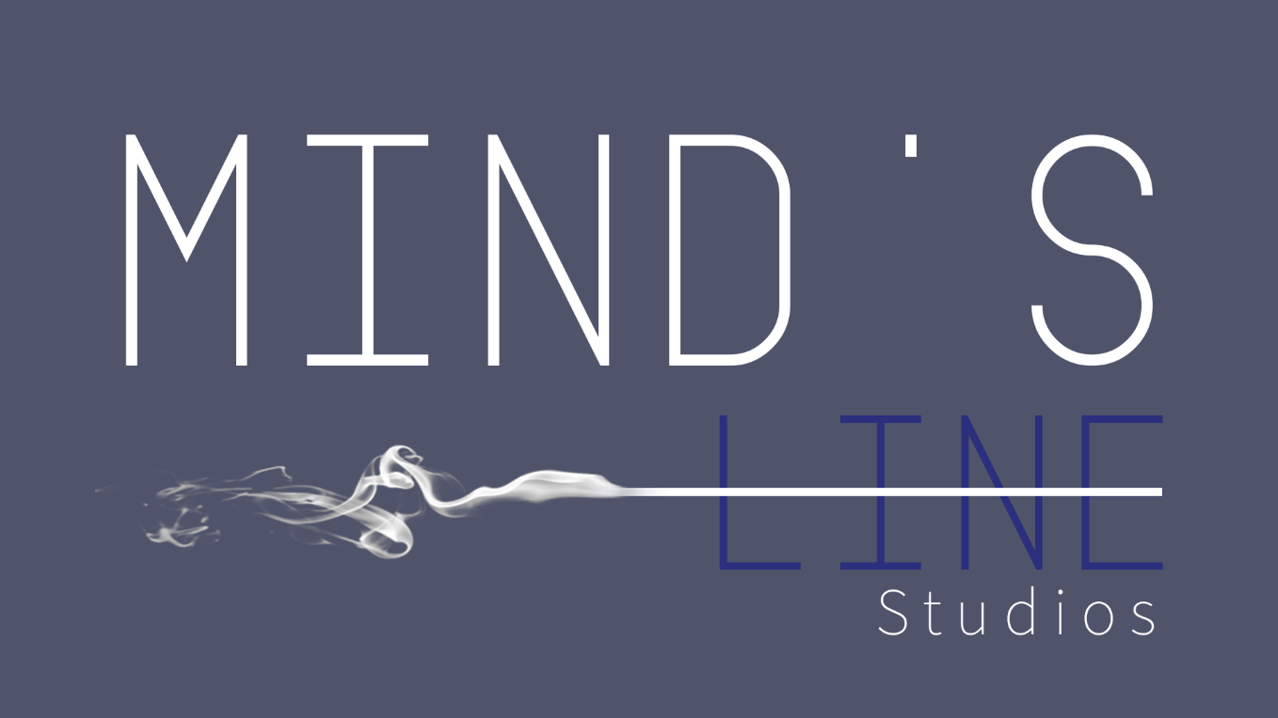
Design Document for:

Mind's Line

A Liminal Space Horror Walking Sim

All work Copyright ©2022 by Mind's Line Studios

By Andrew Carvalho-O'dell, Gonçalo Miranda, Lorena Neagoe, Scott Ollard

Version # 3.0

Monday, May 19, 2022

Table of Contents

NAME OF GAME 1 DESIGN HISTORY 4
VERSION 1.00 4
VERSION 2.00 4
VERSION 3.00 4

GAME OVERVIEW 5
DESIGN GOALS 5
Goal #1 5
Goal #2 5
Goal #3 5
COMMON QUESTIONS 5
What is the game? 5 Why create this game? 5 Where does the game take place? 5 What do I control? 5 How many characters do I control? 5 What is the main focus? 6 What’s different? 6

FEATURE SET 7
GENERAL FEATURES 7 EDITOR 7 GAMEPLAY 7

THE GAME WORLD 8
OVERVIEW 8
SUPERNATURAL ELEMENTS 8
SLOWLY SHIFTING ROOMS 8 WORLD DETAILS 8
Overview 8
Key Locations 8
Travel 8
Scale 8
Objects 9
Time 9 RENDERING SYSTEM 9
Overview 9 Unreal Engine Rendering 9 CAMERA 9
Overview 9
Emphasized Horror 9
Technical Simplicity 9
GAME ENGINE 9
Overview 9
Easy Organization 9
Collision Detection 10
LIGHTING MODELS 11
Overview 11 Office Lighting 11 Hospital Lighting 11

THE WORLD LAYOUT 12
OVERVIEW 12

GAME CHARACTERS 13
OVERVIEW 13

USER INTERFACE 14
OVERVIEW 14
Keeping Immersion 14

SOUND DESIGN 16
OVERVIEW 16 SPOOKY ATMOSPHERE 16

SINGLE PLAYER GAME 17
OVERVIEW 17 STORY 17 PLAYTIME 17 VICTORY CONDITIONS 17

CHARACTER RENDERING 19
OVERVIEW 19

Design History
In the paragraphs bellow, the progression of the game’s development will be detailed, from the initial to it’s last and latest version. With this, the changes and differences between them will be made clear.

Version 1.0
For Version 1.0, we changed how the game would progress and radically changed the idea for the narrative:

- We added a proper narrative, where there wasn’t a proper one before.

- The structure of the first level was changed slightly, new areas were added and some were either moved around or removed.

- The horror aspect was changed to be more clear and direct, since subtle horror might be out of our skill level.

Version 2.0

For Version 2.0, we had to cut some planned ideas due to unforeseen development setbacks, so for the narrative:

- The pamphlets dropping story hints were removed as implementing the idea properly would take too long.

- The shadowy figure quietly following the player was removed for the same reasons as the previous.

- Areas on the third map were removed for the sake of simplicity.

Version 3.0

Game Overview

Design Goals

Goal #1

Create an interesting and unpredictable experience for the player, since the type of storytelling and horror we are trying to recreate is unusual and mainly characterized by it’s unpredictability.

Goal #2

Represent the source material well, as we feel it to be an interesting and unusual method of horror storytelling.

Goal #3

Create memorable and unique visuals, mainly through level design, which is the draw of Backrooms stories.

Common Questions

What is the game?

Mind's Line is a liminal space horror walking sim that is based on the popular creepy pasta called “The Backrooms”.

The game is set in a limbo that looks like a modern high rise office, where an office worker falls asleep and then awakens to explore their new surreal environment. As they walk around the office, they slowly find out what really happened.

Why create this game?
The original creepypasta has recently sparked our interest and we wanted to make our own take on it, with the slight twist of having a proper narrative, which is rare in stories based on our source material.
Where does the game take place?

The game takes place in a high rise office setting, which turns out to actually be a surreal limbo.

What do I control?

The player will control a regular office worker who awakens at their desk.

How many characters do I control?

The player can only control the office worker.

What is the main focus?

The main focus of this game is to find out what the reason for being transported to this surreal reality really is.

What’s different?

Mind's Line is attempting to be a liminal space horror game with a stor, which for this type of game, it’s at best, a rare thing. Additionally, the lack of story is part of the horror, but we are thinking of substituting it with more story.

Feature Set

General Features
Walking Simulator;
Psychological Horror.

Gameplay
The player is tasked with finding and following the path to the next level.
Each level will have an exit or transitionary point that the player needs to find to proceed.

The Game World

Overview
The game world consists of a few floors belonging to a limbo-like reality trying to imitate an office building, which eventually turns into hospital hallways.

Supernatural Elements
As the player progresses, usually normal office rooms would slowly change, eventually turning into an entirely different environment.

Slowly Shifting Rooms
At some point in the game, objects from a hospital would pop up one after another in the office rooms and eventually, the rooms the player would go through are turned into hospital rooms and hallways.

World Details

Key Locations

The Starting Floor: The first floor where the player would begin the game is open to explore, with the intention of making the player comfortable and unaware of the fact that they’ve been transported to an alternate reality.

Long Hallway: Once the player reaches the second floor, they’re presented with an unnaturally long hallway leading to an elevator which will take them to the next level.

Window Room: This is where the player character would first discover that they’re not in the real world and would present the game’s main visual.

Hospital Lounge: The largest room in the game, with the key visual of the game and the first big hint that the levels are shifting to hospital rooms.

Hospital Bedroom: The last room in the game and where the player character would realize what’s happened.

Travel

The only way of traversing through the world is walking. Once the player reaches a transitionary point in the level, they’re teleported to the next level.

Scale

The scale would be somewhat realistic, with the exception of in moments where we want to convey the supernatural aspects of the game and story. The main example would be rooms that are unnaturally sized in comparison to others.

Objects

The game does not feature any interactable objects.

Time

As the player character is transported to an alternate reality/limbo, the in-game time will be static. The time of day shown is daytime, though this is due to an error that couldn’t be fixed due to strange circumstances.

Rendering System

Overview

The objective is to attempt to render the game realistically. Realism is a major elements of Backrooms stories, where the realism contrasted with the unnatural room formations and other supernatural elements is what makes these stories unsettling.

Unreal Engine Rendering

For our game, we’ll use the Unreal Engine, specifically Unreal Engine 4. It’s a great and easy tool to create games, and it’s more than capable of creating ours. It’s rendering engine has been used to create other Backrooms games and to great effect.

Camera

Overview

As is custom in all Backrooms games, the camera we’ll be using is a First-Person camera.

Emphasized Horror

Since the Backrooms’ horror comes from, among other things, it being able to happen to anyone, using a Third Person camera would lessen the effect of the intended horror, as the player would be less able to place themselves in that situation.

Technical Simplicity

On top of a better experience for the player, creating a First Person camera is easier on the developers, since it saves us time that otherwise would have been spent creating, rigging and animating a character.

Game Engine

Overview

Our Game Engine, as mentioned before, will be the Unreal Engine 4.

Easy Organization

On top of other already mentioned aspects, the Unreal Engine makes organizing assets simple and easy. For our environment, the reuse of assets is inevitable, so this aspect of the engine is a big help.

Collision Detection

As for our game’s collision, it will be very simple overall. The main obstacle is to make sure the player doesn’t go anywhere unintended and that doors and other assets in the environment work as intended and keep the player in the right path, while giving them the occasional freedom to look around.

Lighting Models

Overview

We’re trying to achieve realism with our lighting, to better fit the intended style.

Office Lighting

For the office sections of our game, we’re taking inspiration from the typical lighting of a common modern office. The more mundane and common it looks, the better.

Hospital Lighting

For the hospital sections, a more sterile and colder look is the intention. White lights paired with light tones of blue and grey in the environment to give this oppressive yet semi climactic feeling of nearing the end of the journey.

The World Layout

Overview
The layout of the levels is quite simple. Initially, the player has a bit of freedom to move around, but throughout the game, the levels progressively get linear.

Progressive Linearity
At the start of the game, the player will be able to explore one small floor of the office building. There’s a proper way to progress past this level, but they’ll have the freedom to look around.

Game Characters

Overview
The game will have just 1 character: the Office Worker that the player controls.

Character Minimalism
For our Office Worker, we wanted them to be as unintrusive to the player as possible, like a blank slate character, so there’s no real story to the character.

User Interface

Overview
Our aim with the User Interface is to make it minimal. With Backrooms stories, to an extent, the less is shown, the better. So for the purposes of our game, there is no HUD, as there’s no need for one in the game.

Keeping the Immersion
A clean and minimal UI and HUD helps immensely with immersion in any game.
The more the player can see of the world they’re trying to experience, the easier it will be for them to be sucked into it’s universe.

Single-Player Game

Overview

Mind’s Line is a linear single player game, so it’s story is told in a linear way: as the player progresses through the game, the story is revealed to them.

Story
It’s a late night at a Highrise office in NY, where one of the workers just finished writing a report. They’re tired, enough to pass out on their desk. As soon as they wake up, they wonder why no one's come to wake them up, but nonetheless get up to leave, but after crossing a couple of rooms, differences start to show. Rooms seem flipped, doors leading to different rooms than normal and the whole structure of the building seems to have stopped making sense.
Next thing they know, they enter a large empty room, which is normally filled with cubicles, but the real shock is what they see outside the windows: an endless horizon of the same impossibly high building, the building they’re in, standing above the clouds in a starless night sky.
Now in a hurry to get out of wherever they are, they further explore the eerily empty office, now sometimes noticing a shadow out of the corner of their eye. It’s tall, almost shapeless, not resembling anyone they recognize. Before they can have a good look, it vanishes in a fraction of a second. They’re not alone here.
As they move through the rooms, messages start appearing in office posters and in bathroom mirrors, messages that don’t make sense as to why they’d be where they are. Hospital equipment begins to appear, hallways become more sterile and brighter, the furniture changes. By now, they feels compelled to go certain ways, ultimately leading to a hospital room, in which they see themselves, lying unconscious on a hospital bed.
As soon as they open the door, they feel themselves waking up. They passed out due to a tumour in their head acting up for the first time. They realize what that shadow might’ve been: death, an angel? They don’t know.

Playtime
The average playtime should be at about 5 to 10 minutes.

Victory Conditions

Once the final room is reached, the game ends.

Character Rendering

Overview
For our character’s look, there won’t be any. No character model will be rendered, as it’s not necessary for game or narrative purposes.
The game will be played exclusively in a First-Person perspective, and no part of the body is able to be seen from this angle.

Sound Design

Overview
Sound will play an important part in our game. Since the game’s objective is to give the player a mellow yet oppressive environment, level and sound design need to do the heavy lifting when it comes to the atmosphere of the game.

Spooky Atmosphere
Throughout the game, sound will be used to draw the player’s attention to certain events or parts of the room.
Other times, sound will be used to simply keep the atmosphere spooky and tense. The direction and origin of sounds will not always be the same or clear to the player.

