Game Business Plan Template

Contents

1. Confidentiality Agreement
2. Executive Summary
3. Business Focus
3.1 - Mission Statement
3.2 - Business Details
3.3 - Professional Support
3.4 - Management team
3.5 - Project Phases
3.6 - Aims & Objectives
4. Market Research
4.1 - Customer and/or Client Research
4.2 - Evidence of Customer Demand
4.3 - SWOT Analysis
5. Marketing Plan
5.1 - Service or Product
5.2 - Unique Selling Point
5.3 - Pricing Policy
5.4 - Sales & Marketing Strategy
5.4 - Distribution Strategy
6. Financial Plan
6.1 - Start Up Costs
6.2 - Sales Forecasts
6.3 - Cash-flow Forecasts

1. Confidentiality Agreement

The undersigned reader acknowledges that the information provided by TaleLabs LTD in this business plan is confidential; therefore, the reader agrees not to disclose it without the express written permission of TaleLabs LTD.
It is acknowledged by the reader that information to be furnished in this business plan is in all respects confidential in nature, other than information which is in the public domain through other means and that any disclosure or use of the same by reader, may cause serious harm or damage to TaleLabs LTD.
Upon request, this document is to be immediately returned to TaleLabs LTD.
__________________ ___________________
Signature Date
___________________
Name (typed or printed)
This is a business plan. It does not imply an offering of securities.

2. Executive Summary
In this business plan you will be finding information about who we are, what we do and what drives us as a business and a team, but also information about our prices and services, future plans for the business, what we’re offering our customers and how we plan to keep improving and staying on top of everything in this industry.

3. Business Focus

3.1 - Mission Statement
Our mission as TaleLabs LTD is to help our fellow peers and devs with making their visions come true. To put it simply, we help make exciting games that keep players coming back. We create projects that are remembered, combining fascinating mechanics, high-quality graphics, and the implementation of cutting-edge technology.

3.2 - Business Details
TaleLabs LTD is an outsourcing studio founded in 2022 by Lorena-Maria Neagoe, Florin Zamfir and Scott Ollard. We are a remote studio from London. We provide a variety of services from 3D models (textured and untextured), concept art, level greyboxing, rigging and animation.

3.3 - Professional Support
In 2022 we took a business loan of £8,000 to help us cover any initial start-up costs that we will face and get us through the first months of our business until we start earning a profit from our sales.

3.4 - Management team
Lorena-Maria Neagoe – Art Director
An Art Director is focused on maintaining the overall game aesthetics and ensuring the creative process runs efficiently. On top of that, Lorena is also producing concept art.

Florin Zamfir – 3D Artist & Animator
3D artists create three-dimensional creations, including models, animation, and visual effects.

Scott Ollard – Level layout & environment design
Scott creates fantasy landscapes, spooky dungeons and moody wastelands and real-world places like offices and playgrounds too. He often starts with 2D art created by a concept artist and turns it into a believable environment in 3D.

3.5 - Project Phases
Our employees at TaleLabs LTD are capable to adapt to all phases necessary in games production, namely Pre-Production, Production and Post-Production. What phase each employee will be hired for will be discussed with our customers when signing a contract.

3.6 - Aims & Objectives
Short Term
  - Start building a clientele;
  - Get involved in at least 1 small project;

Medium Term
  - We are looking to reach 10,000 in sales in the first year;

Long Term
  - Become an esteemed and well known outsourcing studio;

4. Market Research

4.1 - Customer and/or Client Research
After conducting some market research, we came to the conclusion that the game industry is growing rapidly. In 2021, the video game market in the United Kingdom was worth an estimated £5.89 billion, up from £5.42 billion in the previous year, according to research lead covering internet and gaming, J. Clement.

Sales in the gaming console market decreased in 2022, compared to previous years when many consumers bought products to keep entertained over several lockdowns. The cost of living crisis will also mean that consumers have had to pick cheaper entertainment alternatives. Nevertheless, this financial squeeze is likely to encourage more people to game at home with friends and family as a more affordable option to leisure activities. In the longer term, there will be an increased variety of portable consoles available to consumers, as well as gaming laptops which are comparably cheaper than gaming desktops.

With so much demand for games, studios are racing to put out more and better games than ever before. This is where we come into the picture, helping studios deliver high quality products in a timely manner.

4.2 - Evidence of Customer Demand
For games to be successful, it takes a great team working towards the same goals and visions, which can take a while to build. With how fast games have to be produced nowadays in order to have a chance in this market and not be forgotten, it can be more difficult than ever to build such a team from the ground up. But you can hire it directly, making outsourcing studios very sought after nowadays.. Besides offering full support in the development of the game, saving investors’ costs is another reason why games outsourcing studios are so solicited. We already have what our client needs, from skill to tech and software.

4.3 - SWOT Analysis
Strengths
  - Great prices;
  - Quality products;
  - Great communication with our clients;

Weaknesses
  - New business;
  - Not a lot of clientele in the beginning;
  - Freshly graduated from uni staff, so not a lot of experience in the industry;

Opportunities
  - We can find a lot of great business opportunities at the gaming industry events we will be attending;

Threats
  - Possible communication issues, but to avoid that we will be having multiple meetings (both online and in person) with each of our clients about their projects and their needs;
  - Software we’re using no longer being industry standard in the future, but for that we stay flexible and practice in different programs in our free time;
  - Unexpected events and costs;
  - Security breaches and IT protection. To avoid that we’re using the best cyber security software on our machines, as well as having multiple copies of our work as to not lose anything;

5. Marketing Plan

5.1 - Service or Product
We are planning to offer services and products tailored to our customers’ needs, such as:
- Various types of concept art like character concepts, environmental concepts, art tests etc.
- 3D models: low-poly models, high-poly models, realistic style models, stylized models, all textured or untextured
- Greyboxing
- Character rigging and animation

5.2 - Unique Selling Point
Our USPs are the following:
- Great customer service and communication;
- Quality over quantity;
- Reliability;

5.3 - Pricing Policy
We offer a variety of packages, coming in 3 tiers each, that customers can purchase:

Concept art package:
- Bronze tier: 15 pieces of concept art starting at £300;
- Copper tier: 30 pieces of concept art starting at £600;
- Gold tier: 60 pieces of concept art starting at £1,650;

Textured props package:
- Bronze tier: 3 textured props starting at £600;
- Copper tier: 6 textured props starting at £1,200;
- Gold tier: 12 textured props starting at £3,200;

Greyboxing & level layout package:
- Bronze tier: 1 level greybox starting at £400;
- Copper tier: 1 level layout with all textures included starting at £800;
- Gold tier: 3 fully textured level layouts starting at £2,000;

3D character models package:
- Copper tier: 1 low poly sculpt & rig starting at £700;
- Gold tier: 1 detailed sculpt & rig starting at £1,000;

Animation package:
- Bronze tier: Walk, Run, Jump, Idle animations for low poly character starting at £200;
- Copper tier: Walk, Run, Jump, Idle animations for detailed character starting at £400 / minute;
- Gold tier: 1 cutscene starting at £1,000 / minute;

5.4 - Sales & Marketing Strategy
For our marketing strategy, we split our plans up into online (website, blogging, social media networking) and offline (mail drops, networking events, gaming conventions etc.) strategies.

We didn’t have much of a budget for marketing and had to think of creative ways to market our services.

5.4 - Distribution Strategy
We will send zip files of the product through a secure, confidential link accessible only by us and the potential customer.

6. Financial Plan

6.1 - Start Up Costs
TaleLabs LTD’s startup costs include:
- Bank Loan - £8,000;
- Money we’ve put into the company - £3,000

We don’t have any costs like equipment or licences because we’ve already been paying for them before we even thought about starting a business, when we were still in Uni, so these are no additional costs to us.

6.2 - Sales Forecasts
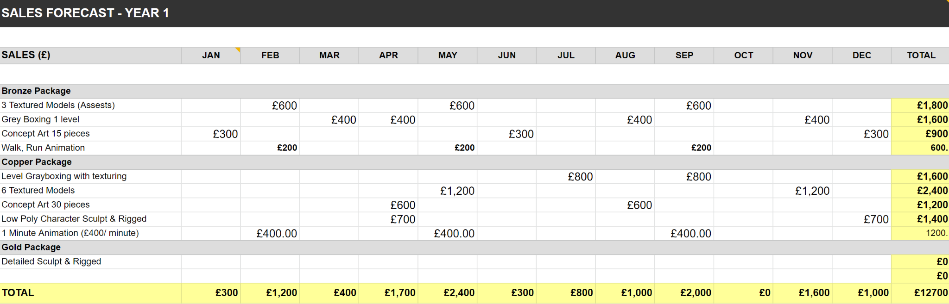

At the end of year 1 we are hoping to have a net profit of about £5,228.

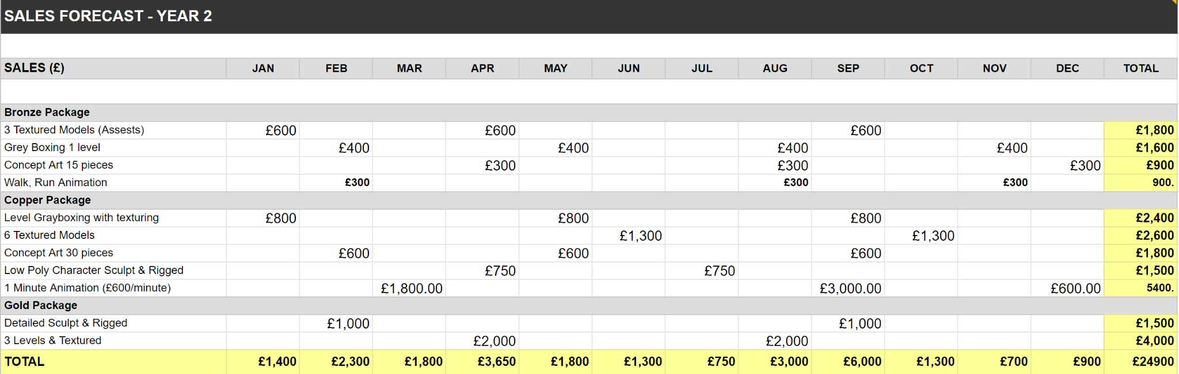

At the end of year 2 we are hoping to have a net profit of about £5,946.
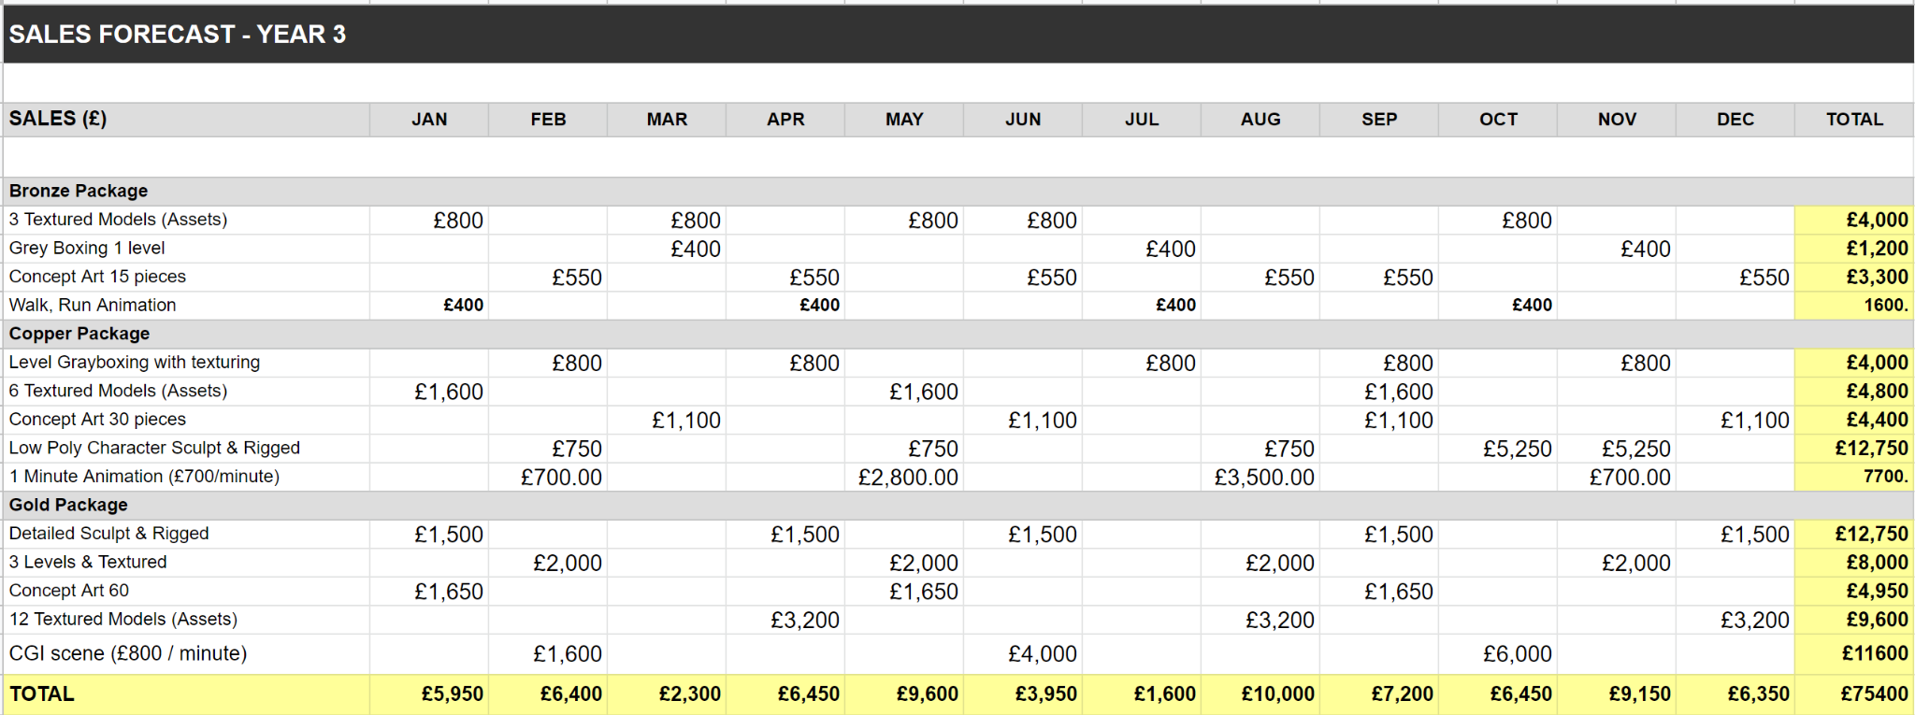
At the end of year 2 we are hoping to have a net profit of about £22,948 due to us offering more services and raising our prices once we gain more experience.

6.3 - Cash-flow Forecasts

